Type | Number of Shots | Price
Staff photo portrait (selection of shots to achieve the best one. 30 min session) | 1 | $55
Land | 5 | $80
Rental | 15 – 20 (Single residential) | $110
Property internal images 4K | Up to twenty images | $135
Property internal images 4K | 20 + (Large Property) | $190
Animated Slideshow | Fifteen images | $25.00
Twilight Photography Shoot | 3 | $75.00
Twilight Photography Shoot Using AI from daytime shot | 1-3 | $25.00
Photo Enhancement - Grass Greening, Sky change.(per photo) | 1 | $5.00
Matt Riley Studio Special | Up to 25 Photos internal, Drone and outside. Normal size 3x1 or 4x2 on single dwelling | $200.00
Acreage Additional Charge | 1 Drone shot | $25.00
Virtual Staging (per photo) | 1 | $50.00
Drone Aerial Photography 5 Images | 5 | $100.00
Drone Aerial Video Flyover | Going from beach/shops etc to Property | $200.00
Video Walk Through | Using slider and motionless gimbal | $250.00
Virtual Tour- 360-degree view  if included with photos of properties. | All rooms in and outside. Virtual Reality. | $180.00
360-degree Virtual tour 10 rooms | Ten rooms max inc bathrooms, Garage | $250.00
Blue screen/green screen podcast video 3 mins (Reps’ professional podcast video) | No more than 3 mins with stereo sound 4k resolution | $395.00 first video branded
All in Special | Drone video and min 5 drone shots, 25 internal photos, up to 90 second video walk through, Twilight 3 shots. | Only $350.00
Call Matthew anytime and arrange your next booking 0459 579 832
Studio Located At 42B Bunbury Street, Busselton WA.
Web Site https://www.mattrileystudio.com/
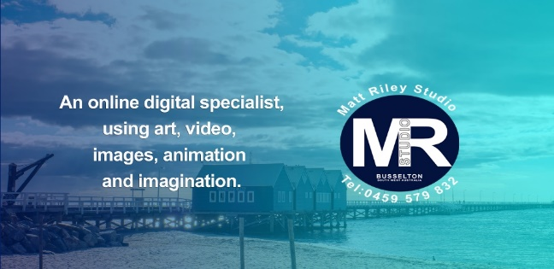
We use the most up to date 4K cameras, software, lighting, royalty free sound and will
always offer our courteous, discreet, and professional service.
Talk to us about FPV drone service.

